Loop Glider

Subject: Aerodynamics, Physics  Related Subjects: Aerospace Engineering | Grade Level(s): 3-6  Length of Lesson: 45 minutes | Type: Project  Keywords: Flight, Lift, Drag, Aerodynamics, Glider Design

Lesson Overview
Students will explore the principles of flight by constructing a simple glider using loops of index cards and a straw. By experimenting with different loop sizes and placements, students observe how shape and balance influence flight performance.

Lesson Focus
How do different shapes and surfaces affect flight? What keeps a glider stable and in the air?

Lesson Objective(s) | - Construct a functional loop glider.  - Understand the effects of lift, drag, and balance on flight.  - Explore how design changes impact flight distance and stability.

Lesson Timing

5 minutes | Introduction to flight and gliders
20 minutes | Construction of loop gliders
10 minutes | Flight testing and modifications
10 minutes | Wrap-up and discussion

Materials | Per Student  - 1 straw  - 1 index card (3” x 5”)  - Masking tape  Shared Tools  - Scissors
Instructor Prep | - Cut index cards lengthwise into thirds if time is limited.  - Set up a clear, open flight test area.  - Prepare a demo glider to show proper loop alignment.

Related Resources

Lesson Plan

Introduction
Ask students: "What helps airplanes stay in the air?" Introduce the basic forces of lift, drag, and gravity. Explain how even small paper gliders need balanced forces and good design to fly well.

Procedure
- Cut a 3x5 card lengthwise into three equal strips.
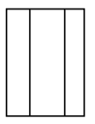
- Form a loop with 1 strip and tape to one end of straw
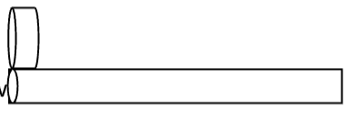
- Tape the remaining two strips together lengthwise and form a larger loop
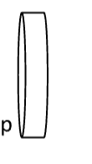
- Carefully align larger loop with small loop and tape to straw
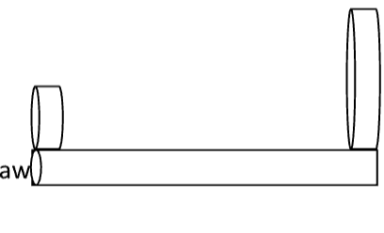

Wrap-up
Invite students to share how their glider flew and what they changed to make it better. Reinforce how loop size and placement affect balance and air resistance. Connect this to real-world glider and airplane designs that rely on shape and airflow for stability.

Lesson Background for Teachers
This activity demonstrates how simple designs can model key concepts of aerodynamics. The loops act like wings, creating drag and stability, while the straw serves as the fuselage. It’s a low-cost way to teach physics through fun, hands-on experimentation.

Suggested Real-World STEM Connections
- Glider planes
- Paper airplane competitions
- Flight stability systems in drones and aircraft

Lesson Variations and Options
- Weighted Gliders: Add a paperclip to the straw’s nose to explore how weight affects glide distance and balance.
- Flight Competitions: Organize challenges for longest flight, straightest path, or most improved design after one revision round.
- Material Variations: Try using paper strips, cardstock, or plastic film instead of index cards to compare material flexibility and performance.

Explanation
The loop glider works by balancing two loops of different sizes on either end of a straw, which acts as the body (fuselage). When thrown, the loops act like stabilizers—similar to wings and tail fins on airplanes—creating drag and helping the glider stay balanced and glide smoothly.

Key Concepts and Vocabulary
- Lift: The upward force that helps objects fly
- Drag: Air resistance that slows motion
- Balance: Equal weight or force distribution for steady flight
- Glider: An aircraft without an engine that flies using lift and gravity

Safety Notes
- Ensure students throw gliders in a clear direction away from others.
- Remind students not to poke with straws or throw too forcefully.

